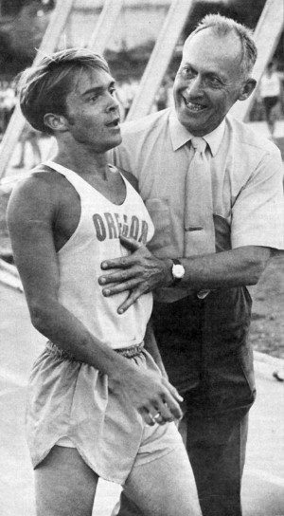
Bill Bowerman (1911-1999) was a revolutionary. He revolutionized the way people run today and also what they wear and run on. He coached track and field at the University of Oregon from 1948 to 1973. In 1962 he went to New Zealand and was inspired by the thousands of everyday people jogging on the side of the road. When he got back to America he wrote a book called Jogging, which got thousands of people to start running, and created popular community run clubs in Eugene, OR. He also co-founded Nike with Phil Knight and is credited with inventing some of Nike’s best running shoes.
Bill Bowerman congratulating Steve, one of the best Oregon track runners ever. Source: Sports Illustrated 1970
Source: Sports Illustrated 1970

